1. **Introduction**

1.1 Overview

The iPhone is a smartphone made by Apple that combines a computer, iPod, digital camera and cellular phone into one device with a touchscreen interface. It would support third party applications using the Safari engine, and designs, manufactures, and markets smartphones, tablets, personal computers, and wearable devices

1.2 Purpose

We just learnt how to use the tableau for the upcoming year now. It's helpful to do statistics and about data analytics for future reference. We achieved that team works to make powerful things.

1. **Problem Definition & Design Thinking**
   1. Emapthy map

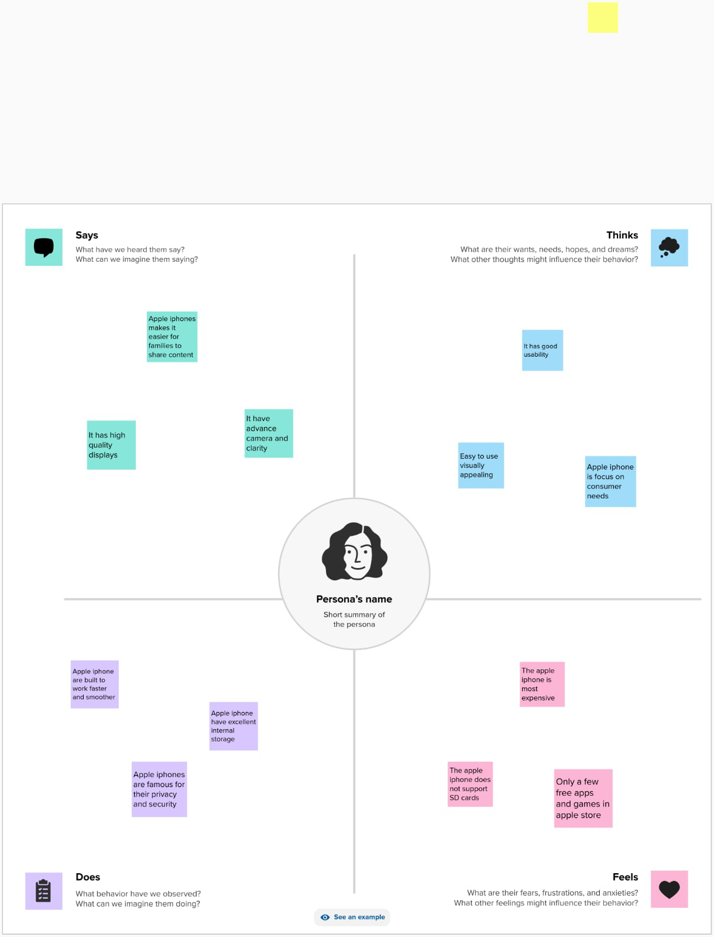

* 1. Brainstroming Map

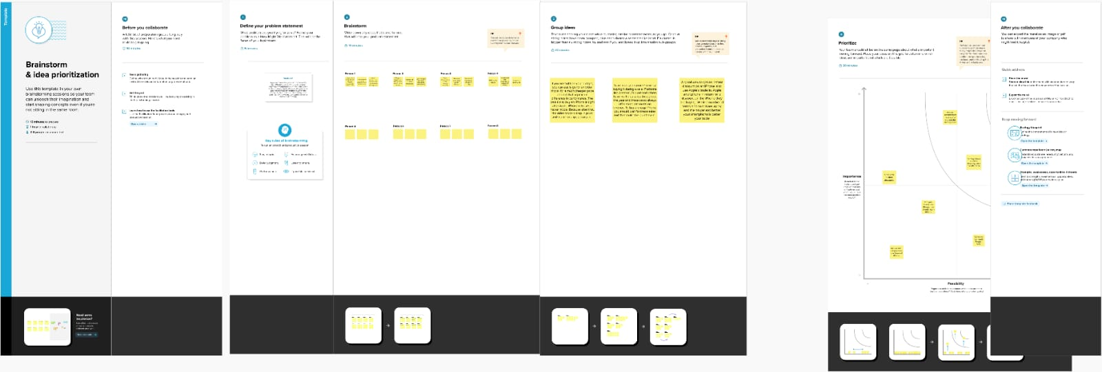

1. **Result**

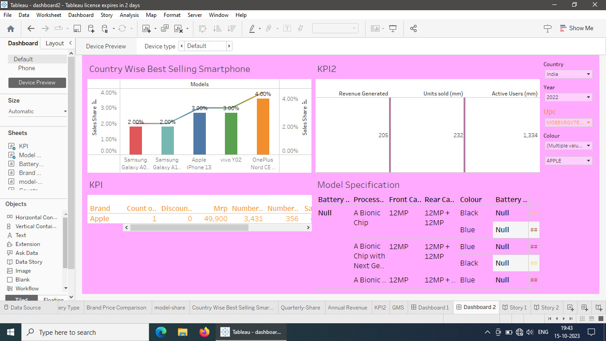

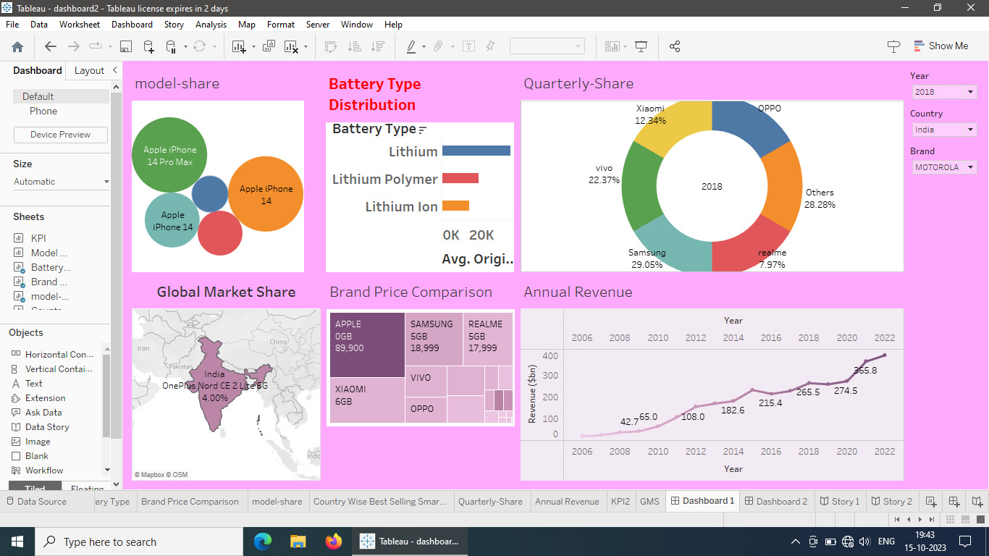

**4. Advantages and disadvantage**

Advantages of Apple iPhone:

* User-Friendly Interface
* High-Quality Display
* Advanced Camera
* Faster processor

Disadvantage of Apple iPhone:

* Cost
* Non-Removable Battery
* Limited Customization
* No Expandable Storage
* Highest GST

**5.Applications:**

* Communication
* Internet Browsing
* Social Media
* Entertainment
* Navigation
* Photography
* Education

**6. Conclusion:**

iPhones have had a significant impact on mobile technology, setting new standards for user experience, app development, and mobile photography. While Apple has faced competition from other manufacturers, its commitment to innovation and ecosystem integration continues to make the iPhone a prominent and influential product in the tech world

**7. Future Scope**

Hardware Innovation, 5G and Beyond, Sustainability, Service ecosystem Market expansion, Security and Privacy then Augmented Reality and so on